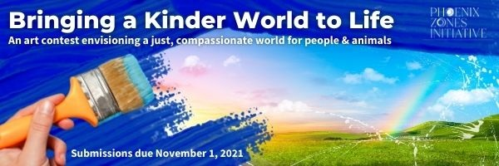

**Bringing a Kinder World to Life Art Contest** **Submission Form**

Entrant's Name: ______________________________________________________________________

Category (mark one): ADULT YOUTH Your age, if you're 18 or younger: ______________

Your city/state: ______________________________________________________

Your email: __________________________________________________________

Your phone number: __________________________________________________

Title of your submission: _________________________________________________________________

Brief statement about your piece and how it relates to the theme:

□ I certify that this work is my original work and does not violate any copyright, trademark, or other intellectual property laws or the rights of any third party.

□ I consent to the use of my original artwork submission by Phoenix Zones Initiative. This consent applies in all forms known now or in the future, in all media and in all manners, including, but not limited to, advertising, art, editorial, electronic, and exhibition. Please review and assent to the full license you are granting to Phoenix Zones Initiative [here](https://www.phoenixzonesinitiative.org/wp-content/uploads/2021/09/2021-art-contest-rules-phoenix-zones-initiative-92021-PDF.pdf).

Entrant Signature:________________________________________________________________________

Parent/guardian signature if Entrant is under 18:_______________________________________________

□ I would like to sign up for Phoenix Zones Initiative’s newsletter.